Q1: Write a C program and implement Proteus simulation and the physical setup for a Knight Rider LED chaser, where the direction of the light movement is controlled by a switch. In this implementation, when the next LED lights up, the previous LED should remain ON.

Code

sbit sw at RA2_bit;

void rider() {

char x;

int i;

TRISB = 0b00000000; // Set PORTB as output

TRISA = 0b00000100; // Set RA2 as input (SW connected)

if (sw == 1) {

PORTB = 0b00000001;

Delay_ms(200);

x = 0b00000010;

for (i = 0; i < 7; i++) {

PORTB = PORTB | x; // Keep previous LEDs ON

x = x << 1;

Delay_ms(250);

}

} else {

PORTB = 0b10000000;

x = 0b01000000;

Delay_ms(200);

for (i = 7; i =< 7; i--) {

PORTB = PORTB | x;

x = x >> 1;

Delay_ms(250);

}

}

}

void main() {

CMCON = 0x07; // Disable comparator

TRISA = 0b00000100; // RA2 as input

TRISB = 0x00; // PORTB as output

PORTB = 0x00;

while (1) {

rider();

}

}

Q2: Create a LED chaser pattern where it begin from the middle and going to go to the two ends

void knightrider(void) {

int i;

char left = 3;

char right = 4;

TRISB = 0x00;

PORTB = 0x00;

for (i = 0; i < 4; i++) {

PORTB |= (1 << left); // Light LED from center to left

PORTB |= (1 << right); // Light LED from center to right

Delay_ms(200);

left--;

right++;

}

}

void main() {

CMCON = 0x07;

while (1)

knightrider();

}

Code

Q3: Create a LED Chaser Pattern where the light movement skips a LED and continue.

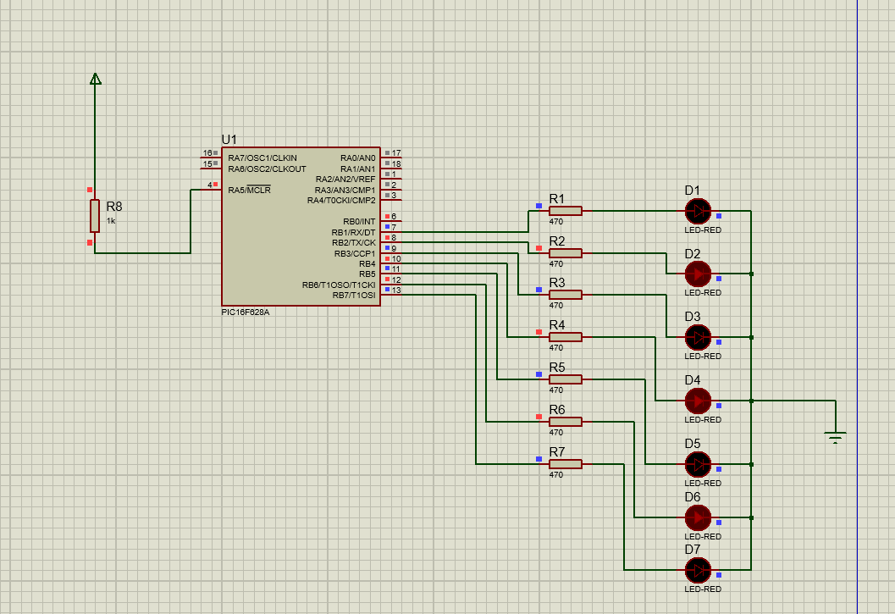

Code

void knightrider(void) {

int i;

TRISB = 0x00;

PORTB = 0x00;

for (i = 0; i <= 6; i += 2) {// Forward skipping LEDs

PORTB |= (1 << i);

Delay_ms(150);

}

for (i = 7; i >= 1; i -= 2) {// Backward skipping LEDs

PORTB |= (1 << i);

Delay_ms(200);

if (i == 1) break; // Prevent infinite loop

}

}

void main() {

CMCON = 0x07;

while (1)

knightrider();

}

